United Nations Development Programme
Programme of Assistance to the Palestinian People

Country: State of Palestine

Donor: King Salman Humanitarian Relief Centre

Project: Emergency WASH Intervention for Relief in the Gaza Strip
PAL-10-1003571
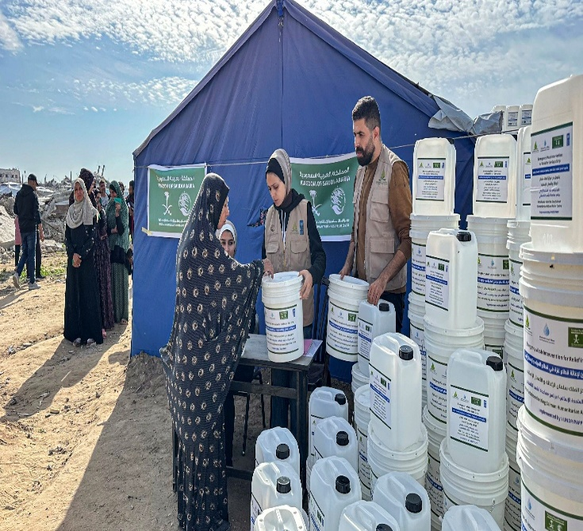
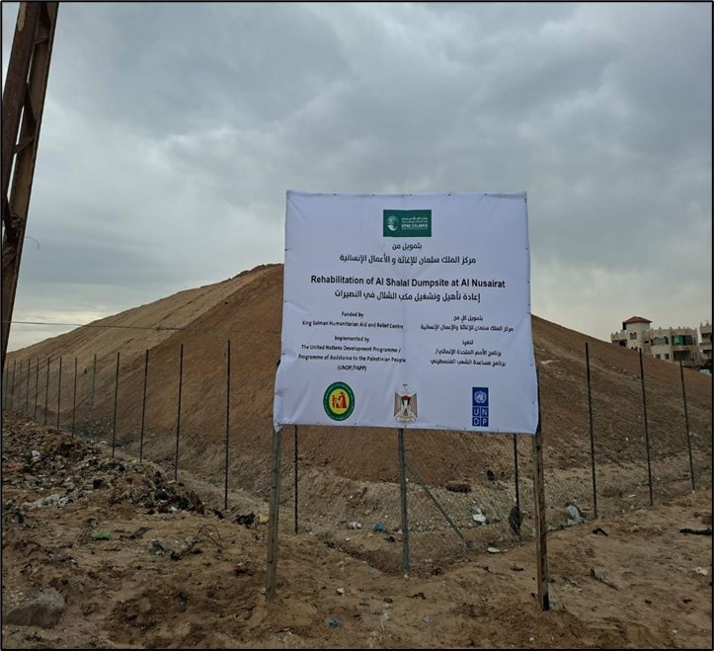

Monthly Report 10
March/May 2026

Table of Contents

- Project Report Summary Sheet

- Project Overview
  - Background and Project Rationale
2.2 Purpose and Expected Results

3. Review of achievements and implementation
3.1 Achievements for the Reporting Period
3.2 Assessment of Project Performance

4. Enabling Performance Factors
4.1 Participation
4.2 Coordination

5. Cross-cutting issues

6. Main Challenges and constraints

7. Donor visibility

8. Recommendations

9. Financial Information

10. Annexes

- Pictures and description from work sites

- Approved financial report (stamped and signed)

- Other relevant documents
- Project Report - Summary Sheet

Project title | Emergency WASH Intervention for Relief in the Gaza Strip
Country & Location | Gaza, Palestine
Project dates | Agreement signature date |  | 24 Feb.2025
Project dates | Project Duration |  | 19 months
Project dates | Start date |  | Original |  |  | Actual
Project dates |  |  | 24 Feb. 2025 |  |  | 24 Feb 2025
Project dates | End date |  | Original |  |  | Actual
Project dates |  |  | 24 Feb. 2026 |  |  | 15 June 2026
Implementing partners details
Type | a United Nations ☐ International non-governmental organization ☐ Local non-governmental organization ☐ Others
Partner Name | United Nations Development Programme/Programme of Assistance to the Palestinian People- UNDP/PAPP
Focal Point | Mohammad Mezyad
Telephone | +970-595606792
E-mail | mohammad.mezyad@undp.org
Budget Summary (in USD)
Project Budget | US$ 4,653,465
Total Received | US$ 4,188,068.5
Percentage of total received | 90%
Progress Summary
Planned Percentage of completion |  | 88 %
Actual Percentage of completion |  | 80 %
Type of report
a Periodic monthly report #10 | Period covered: |  |  | from | 15 March 2026 |  | to | 15 May 2026
Executive Summary: (Brief summary of project performance)
The project addresses the urgent needs of the Gaza population, heavily impacted by the ongoing intense warfare in Gaza, resulting in unprecedent destruction of infrastructure and affecting every aspect of Gazans’ livelihoods. The crisis is further compounded by the severe restrictions in terms of access of much needed humanitarian assistance into Gaza, as well as the ability of humanitarian and early recovery actors to distribute the aid, as well as access and assist the population in need. The ongoing evacuation orders by the Israeli army have resulted in overcrowding and unprecedented stress on provision of all essential services - which are already overstretched because of the widespread destruction and limited resources.
Consequently, this intervention focuses on two essential services: water and solid waste management. The progress summary of works up to 15 May 2026 is indicated below against expected project outputs.

Output 1.1: Safe drinking water supplied to the most vulnerable communities, with a focus on IDPs.
- Procure five potable water distribution tankers of 10 m3 capacity: UNDP procurement department has already implemented a Long-Term Arrangement (LTA) for the supply of trucks and launched the Mini bidding for the best offer for the 5 tankers. The mini bidding procurement process was completed, and 3 offers were received. A contract was signed, and the 5 water tanks are manufactured and was delivered to Aqaba in January 2026 and accessed Gaza in May 2026, for handover to the PWA in June 2026. A payment of 50% was made for the cost of the tankers against Bill of Lading; the remaining amount will be disbursed by the implementation end date, upon receipt of the third instalment from the donor.
  - Supply timeline and procedures undertaken:
- 5 water trucks were procured from Shacman company.
- The contract with the contractor was signed on 22/7/2025.
- The third party inspection was conducted on 9/12/2025 (report attached).
- The trucks arrived at Aqaba Port, Jordan, at the end of January 2026.
- The trucks were stored in a warehouse in Aqaba together with their spare parts, pending completion of entry procedures into the Gaza Strip. In May 2026, the trucks entered Gaza, whilst spare parts remain in Aqaba awaiting approval.
- Spare parts approved for entry, awaiting confirmation of access coordination by COGAT. Expected to enter in June 2026, and remain stored in Aqaba – with storage costs covered by the third instalment.

CoGAT approval procedures:
- The request was submitted on the 2720 platform on 2/10/2025 under request number 3614.
- The request was approved on 17/11/2025.
- A resubmission was requested as per entry procedure requirements on 7/4/2026 following the arrival of the trucks at Aqaba Port.
- The week of 24/05/2026, approval was received for entry of the 5 trucks, and they entered Gaza on 25/05/2026.
- On 26/05/2026, the 5 trucks were inspected by UNDP and a joint committee with PWA. The 5 trucks were formally handed over to the PWA in June 2026.

- 1.1.2 Trucking services to the population in the Gaza strip distributing 1,800 m3/ day utilizing 36 water tankers for transportation. UNDP signed agreements with two local NGO as implementing partner for water trucking activity in Northern and Southern Wadi Gaza for the distribution of 900 m3 per day by each IP. In addition to signing one agreement with one local NGO as implementing (IP) for community engagement and crowd management in water trucking project. The distribution of clean water for the IDPs in Gaza city and Khan Younis city continued and 67,612 M3 were distributed in the reporting period (15 March 2026 to 15 May2026) in Gaza, Deir Al Balah and Khan Younis city, and the total cumulative quantities distributed is 348,919 M3. The savings from the budget (due to fuel costs being lower than predicted), estimated at approximately $ 285,000 were reallocated to water trucking activities to ensure the continued provision of safe drinking water to IDPs, to be covered through the third instalment. This is particularly critical given the current shortage of safe water and the anticipated increase in demand during the summer season. With the available budget, an additional 52,000 m³ of water will be distributed and the project will end in the mid of June 2026.
- 1.1.3 Supply and distribution of Jerrycans and Buckets to help displaced people to store the quantities of water received through trucking services: 3000 jerricans were manufactured locally and distributed to IDB families. In parallel, UNDP procurement has completed the process to provide the rest of the quantities (40,032) from outside Gaza. The full quantity is manufactured, and UNDP managed to access the whole quantity of jerricans and buckets to enter into Gaza from the West Bank through Gaza crossings. All jerrycans and buckets have been distributed to the IDPs in the Gaza strip.

Output 1.2: Enhanced solid waste management capacities of local municipal institutions and affected communities.
- 1.2.1 Contribution to waste collection and transport of solid waste in South Gaza by the private sector: An Expression of Interest (EOI) was launched to identify interested Implementing Partners (IPs). The evaluation process and the selection of the IP have been completed, and the agreement with the selected IP (CESVI) was signed. Following this, private contracting companies were selected to carry out waste collection of the remaining quantities, and the operations started on 27 December 2025; the waste collection by the implementing partner (CESVI) is covered by two sources of fund including the KSR and other contribution. Meanwhile, direct contracting with private contractors and implementation through CESVI have resulted in the collection of a total of 27,840 m³ of waste in the southern Gaza Strip to date.

- Activity 1.2.2 Contribution to waste collection and transport of solid waste in North Gaza by the private sector: Similar to the South Gaza intervention, an EOI was issued, and the evaluation of the interested IPs has been completed, and the agreement with the selected IP (CESVI) was signed. The selected IP completed the selection of contractors responsible for waste collection, and the operations started on 27 December 2025; the waste collection by the implementing partner (CESVI) is covered by two sources of fund including the KSR and other contribution. Meanwhile, direct contracting with a private contractor and implementation through CESVI have resulted in the collection of a total of 28,044 m³ of waste in the northern Gaza Strip to date.

- Activity 1.2.3 Employ workers to contribute to waste removal and supervise fuel distribution mechanisms: The Gaza Culture and Development Group (GCDG) has been selected as the IP for this activity. An agreement has been signed, and GCDG is responsible for hiring fuel monitors and field supervisors. GCDG has been working with UNDP on a similar scope since September 2024, demonstrating both the capacity and experience required. This activity commenced in August 2025 by partially covering the fuel monitors. By September 2025, it expanded to cover all fuel monitors and controllers as well as the field supervisors. By October 2025, the entire budget allocated for fuel monitoring had been fully utilized. Starting from October 2025, Part of the fuel monitoring costs were supported through other funding sources.

- Activity 1.2.4 Rehabilitation and operation of temporary dumping sites: The designs for two dumping sites; Al-Shalal in Al-Nuseirat and Al-Maghazi, have been completed. Part of the rehabilitation of Al-Shalal dumping site was financed under this fund, while the rehabilitation of Al-Maghazi dumping site was supported through another funding source. The procurement process for the rehabilitation of Al-Shalal dumping site has been completed, and implementation commenced on 18 September 2025, and it was reported that 100% of the activities have been completed; preparation of the site and the reshaping activity have been completed, and 100% of the coverage by clay was completed. It is worth noting that, after receiving the offers, it was found that the project cost exceeds the allocated budget; therefore, part of the activities was financed through another funding source.

- Project Overview

  - Background and Project Rationale
The events following the October 7 attack by Hamas, and the ensuing war declared by Israel, have severely impacted the already critical humanitarian situation in the Gaza Strip, adversely affecting over 2.2 million of its residents.
According to recent UN estimates, 1.9 million people (almost 90% of the population) are estimated to be internally displaced (as of July 10), including many who have been displaced multiple times, as families are forced to move repeatedly searching for safety. This has led to severe overcrowding and exacerbated the disruption of essential services - which are already overstretched because of the widespread destruction and limited resources during the ongoing war.
Water and sanitation facilities stopped due to the power outage, affecting the whole population in the Gaza Strip, and causing water pollution-related diseases. Water production was reduced to 25% and Israeli water company (Mekorot) supply was also reduced to 60%. Despite all ongoing efforts by international actors to secure a reasonable amount of water for drinking and domestic use, the current supply does not meet the minimum recommended quantity.
Forced internal displacement from various areas of the Gaza Strip according to the repeated evacuation orders, coupled with a severe shortage of fuel supplies and destruction of more than 200 waste collection trucks, has led to the severe disruption of solid waste collection and transportation services. This has resulted in the accumulation of waste on the streets to unprecedented levels, both within residential areas and around shelters for displaced persons, posing an imminent threat of environmental disaster and an increased risk of diseases among the displaced and the host communities. The inability to access the two main landfills in the Gaza Strip has led municipalities to establish temporary dumping sites. A total of 141 temporary dumping sites of varying sizes have been created throughout the Gaza Strip, some of which require urgent closure or removal due to their risks to the environment and public health.
Consequently, this intervention focuses on two essential services: water supply and solid waste management.
The project ultimately seeks to contribute to strengthening the socio-economic resilience of the Palestinian people, including greater self-reliance, enhanced ownership and leadership, and cohesive identity. It contributes to ensuring that Palestinians in the Gaza Strip, especially those most affected and vulnerable, have access to inclusive and quality public and basic services.

  - Purpose and Expected Results

To ensure sustainable improvements in access to safe drinking water and wastewater management in Gaza, a comprehensive multi-year strategy is needed over a three-year period. This strategy is designed to address both immediate humanitarian needs and long-term infrastructure recovery, with a focus on resilience, capacity building, and climate adaptation. The expected outputs are:
Output 1.1: Safe drinking water supplied to the most vulnerable communities, with a focus on IDPs.
The intervention will facilitate the arrangement between the Local Governmental Units (LGUs) and water contractors, ensuring the daily distribution of water at a rate of 3 litres per person for 600,000 people, both in the identified IDP shelters and in agreed locations for host communities. In addition, the intervention will support the procurement of essential critical items of household water containers, to facilitate storage and water transmission to the houses.
Output 1.2: Enhanced solid waste management capacities of local municipal institutions and affected communities.
The intervention will support the collection and transfer of solid waste, which has been accumulating in the streets as a result of overcrowding in the south of the Gaza Strip and breakdown in municipal service provision due to the ongoing war. Restoring municipal capacities for solid waste collection and transfer will contribute to improved hygiene and sanitary conditions and safer environment for IDPs and host communities in the targeted geographic areas.

- Review of achievements and implementation

  - Important achievement for the reporting period (by activity)

Activities | Target | Achievement | Achievement (%) | Deviation narratives  (If applicable)
1.1.1 Procure five potable water distribution tankers of 10 m3 capacity. | 5 Tankers | The 5 trucks entered Gaza from Aqaba, while spare parts remain stored in Aqaba pending access coordination approvals. | 100% | - The 5 tankers were manufactured and delivered to Aqaba in January 2026. In May 2026, the 5 tankers entered Gaza and were inspected, for handover to the PWA in June 2026.  - Spare parts remain stored in Aqaba; approved by COGAT but awaiting entry coordination.  - The lowest offer was 9.8% greater than the Item budget line of the project (as previously reported).
1.1.2 Trucking services to the population in the Gaza strip distributing 1800 m3/ day utilizing 36 water tankers for transportation. Activities will include facilitation of an arrangement between the operator of available installed units and private contractors to transport desalinated water daily to displaced people and targeted host communities. | 108,000 m3 | 67,612 m3 | 62.6 % | - The distributed quantities are less than the anticipated monthly quantities due to:  -Insufficient water sources and recurrent interruptions of the Israeli water supply (Mekorot)  - Lack of adequate water tankers to carry on the transportation of water.  - Cut off occurred in Mekrot water line in the north in  January and February and from 18-04-2026 till now.
1.1.3 Supply and distribution of Jerrycans and Buckets to help displaced people to store the quantities of water received through trucking services. | 43,032 | 3000 delivered to IDPs in Gaza and 40,032 manufactured in the West Bank and transported to Gaza | 100% | 3000 jerricans were manufactured locally, and the remaining 40,032 is manufactured all of them entered to Gaza, and distributed to IDPs in Gaza strip.
Activity 1.2.1 Contribution to waste collection and transport of solid waste in South Gaza by the private sector | 40,200 | 27,840 m3 | 100 % | The waste collection was initiated through a direct contract between UNDP and a contracting company. The total quantity collected by the direct contracting with UNDP in South Gaza is 9,840 m3.  The work through the UNDP Implementing Partner started on 17 of December using two source of fund (KSR and another source of fund). The contribution of KSR succeeded to collect 18,000 m3 in South of Gaza Strip.  The total collected quantity is 27,840 m3. This intervention is completed, but only the fuel invoice is still pending payment to UNOPS.
Activity 1.2.2 Contribution to waste collection and transport of solid waste in North Gaza by the private sector | 40,200 | 28,044 | 100 % | During the proposal stage, the cost estimates for waste collection were based on the assumption that fuel would not be available in North Gaza and thus reflected high market prices. However, since UNDP is now able to provide fuel directly, the overall cost of the service has decreased considerably. As a result, the same budget allows for the collection of additional quantities of waste.  Direct contracting by UNDP resulted in collecting 28,044 m3 of waste. This intervention is completed, but only the fuel invoice is still pending payment to UNOPS.
Activity 1.2.3 Employ workers to contribute to waste removal and supervise fuel distribution mechanisms | 2 months | 2 months | 100 % | The agreement has been signed with the Implementing Partner (GCDG), and they deployed the fuel monitors and started from August. Part of the fuel monitors was covered; all the fuel monitors and field supervisors were covered during September and part of October 2025. The allocated budget was fully consumed.
Activity 1.2.4 Rehabilitation and operation of temporary dumping sites | 2 dumping sites | 2 | 100% | The rehabilitation design of two dumpsites has been completed. Part of the rehabilitation of Al-Shalal dumping site was covered by this fund, and the implementation of this rehabilitation activity was completed.  The design of Al-Maghazi dumpsite was completed, whereas the implementation of this rehabilitation activity was also completed by using another source of fund.

Achievement table based on activities weight value

# | Activities | Target | Achievement | Allocated budget | Achievement percentage (%) | Weight Value | Actual Achievement percentage (%) | Deviation narratives
1 | 1.1.1 Procure five potable water distribution tankers with 10 m3 capacity. | 5 | The trucks are manufactured, inspected, entered Gaza, and were handed over to the PWA for operation. | 500,000.00 | 100% | 11.7% | 11.7 | The signed contract for the trucks is 9.8% higher than the estimated value in the budget
2 | 1.1.2 Trucking services to the population in the Gaza strip distributing 1800 m3/ day utilizing 36 water tankers for transportation. Activities will include facilitation of an arrangement between the operator of available installed units and private contractors to transport desalinated water daily to displaced people and targeted host communities. (Detail breakdown of cost available in fuel tab) | 324,000 | 348,919 m3 | 2,388,720.00 | 107.7 % | 55.7% | 59.98 | - Availability of enough water sources.  - Availability of adequate distribution tankers.  - distance between distribution locations.  - Fuel shortage  - To address the shortage of water from the Mekorot source in northern Gaza and bridge critical gaps, UNDP arranged to procure subsidized water from private desalination plants in response to the urgent and pressing needs of internally displaced persons (IDPs).
3 | 1.1.3 Supply and distribution of Jerrycans and Buckets to help displaced people to store the quantities of water received through trucking services. | 43,032 | 43,032 | 301,224.00 | 100% | 7.0% | 7 | The procurement process is complete, and the contractors deliver the 43,032 jerricans and buckets to Gaza.
4 | 1.2.1 Contribution to Waste collection and Transport of solid waste in south Gaza by the private sector for 2 months. | 40,200 | 27,840 | 305,760 | 100% | 7.1% | 7.1 | The total collected quantity in South of Gaza is 27,840 m3. This intervention is completed, but only the fuel invoice is still pending payment to UNOPS. The fuel payment is related to the quantity of fuel used for the collected waste under this project. Hence, re-allocation between activities was made, The updated budget for this activity is 266,545.08 US$.
5 | 1.2.2 Contribution to Waste collection and Transport of solid waste in North Gaza by the private sector for 2 months | 40,200 | 28,044 | 270,000 | 100% | 6.3% | 6.3 | The total collected quantity in North of Gaza is 28,044 m3. This intervention is completed, but only the fuel invoice is still pending payment to UNOPS. The fuel payment is related to the quantity of fuel used for the collected waste under this project. Hence, re-allocation between activities was made; the updated budget for this activity is 243,345.3 US$.
6 | 1.2.3 Employ workers to contribute to waste removal and supervise fuel distribution mechanisms. | 2 months | 2 months | 42,000.00 | 100 % | 1.0% | 1% | We started covering the fuel monitoring by using this fund in August, and the budget was fully consumed by End of October 2025.
7 | 1.2.4 Rehabilitation and operation of temporary dumping sites | 2 | 2 | 104,630.38 | 100 % | 2.4% | 2.4 | The rehabilitation design for two dumpsites has been completed. Only part of the rehabilitation of Al-Shalal dumping site was covered by this fund. The rehabilitation of Al-Shalal started on 18 September, and 100% of the work was completed. Hence, re-allocation between activities were made, the updated budget for this activity is 170,500 US$ including the design of the two dumping sites, the contribution to construct Al-Shalal dumping site, and the fuel coverage for Al-Shalal dumping site covering the KSR works.
8 | Infrastructure Project Manager |  | 80,750 | 89,499.00 | 90% | 2.1% | 0.97
9 | Quality Assurance - Water Supply 20% |  | 17,899 | 17,899.80 | 99% | 0.4%
10 | Project Engineer |  | 60,229 | 61,084.17 | 98.6% | 1.4% | 1.75
11 | Site Engineer |  | 39,604 | 29,999.98 |  | 0.7%
12 | Quality Assurance - Solid Waste 20% |  | 22,278.34 | 22,278.34 | 100% | 0.5% | 0.5
13 | Project Manager - Solid Waste 50% |  | 28,200 | 44,749.50 | 63% | 1.0%
14 | Project Environmental Coordinator - 76% |  | 0 | 55,708.76 | 0 | 1.3% | 0
15 | Field Environmental Supervision Engineers (UNV) |  | 32,646.94 | 27,000.00 | 120.91% | 0.6% | 0.73
16 | Portfolio Associate 23% |  | 16,900 | 16,900.35 | 99% | 0.4% | 0.4
17 | Supporting Services Cost (Solid Waste) |  | 3,159.03 | 12,642.72 | 24.9%
18 | Details in Visibility and Advocacy tab |  | 8,515 | 8,516 | 99% | 0.3% | 0.95

3.2 Assessment of Project Performance
Output 1.1: Safe drinking water supplied to the most vulnerable communities, with a focus on IDPs.
The project implementation is facing challenges, where the potential distribution locations are being identified and recorded for the number of trucking activities, at the same time, the water sources to cover the quantities required by the project is also being identified where is a possibility to contract private desalination plant to cover the deficit from the main Mekorot water supply line. On the other hand, the current ceasefire in Gaza strip has profoundly increased the demand for the delivery of the quantities stipulated in the contract. A contract was signed for the supply of the 5 water trucks, and the tankers are ready for shipping into Aqaba then to Gaza. On supply of jerricans and buckets activity, 3000 jerricans were procured and distributed to IDB families and the remaining 40,032 jerricans and buckets are manufactured in the West Bank transported to Gaza after granting the Access approval from the Israeli authorities.
Output 1.2: Enhanced solid waste management capacities of local municipal institutions and affected communities
The project has moved forward since the last reporting period. To date over 55,884 m³ of waste has been collected against the target of 40,200 m³, representing more than 100% of the planned quantity. The design for the two dumping sites has been completed, As well the procurement process for implementation of Al-Shalal dumping site has been completed and the site was handed over on 18 September 2025 and 100% of the workers were completed. It is worth noting that, after receiving the offers for the rehabilitation of Al-Shalal dumping site, it was found that the project cost exceeds the allocated budget; therefore, part of the activities will be financed through another funding source. The implementation of the second dumping site was covered from another source of funds, and it also was completely implemented by end of February.

- Enabling Performance Factors

In addition to the information provided in the Performance Tables this section is concerned with several factors which influence project performance factors. The following areas and related questions are to be considered.

- Participation - To what extent were beneficiaries and local delivery partners involved in the assessment, design, implementation, M & E and learning? Did beneficiaries take on any special roles or duties (leader, social facilitator etc.)?
A set up configuration is composed of the PWA, UNDP, municipalities, WASH cluster and the IP. The PWA and the WASH cluster, through published phone numbers receives calls from the focal persons of each IDP shelters or makeshift shelters or schools. They coordinate with the UNDP on the identified needs and then through the IP, one water tanker with 15m3 capacity with a monitor and assistant get in contact with the focal person and the water is discharged to the beneficiaries accordingly. The banners for the donor’s visibility and contacts to raise claims or issues are being posted on each water tanker to ease the communication between the beneficiaries and project team.
All solid waste activities were designed in consultation with relevant partners and service providers. UNDP developed an immediate interventions plan in 2024, and the current activities fall under this plan. Additionally, the proposed interventions were identified and prioritized by the Solid Waste Management Task Force operating under the WASH Cluster.

- Coordination - To what extent were project efforts coordinated with the work of other groups in the area and with relevant multi-stakeholder policy and agreements? How well did the coordination work? What has been the biggest success in the coordination and what were the gaps?
PWA as water sector regulator in coordination with the WASH cluster and municipalities receive updates from the local and international actors of water trucking and at the same time receive appeals from the IDP’s and other groups in need. Based on that, PWA has representatives in each governorate, and they carry on the coordination between all stakeholders to serve and respond to the needs for drinking water for all the IDP camps and makeshifts. The WASH cluster established an online log for the quantities and location of water distribution and at the same time responds and coordinates the requests and distribution of fuel for the water trucks.
All the Solid Waste Project activities were closely coordinated with key actors through the Solid Waste Management Task Force under the WASH Cluster, ensuring alignment with ongoing interventions and avoiding duplication.

- Cross-cutting issues
Please describe how the project addressed the following cross-cutting issues during the reporting period

Issue | Description
Gender and equity | - All personnel involved in the project follow the Code of Ethics and conduct manual, gender policy, child protection policy, security, and Safety policy, anticorruption policy, internal control system, project management procedures, operational manual, and MEAL framework ensuring that affected women breadwinners and female and male youth graduates are treated with respect and dignity, have their welfare promoted and receive support in an environment in which efforts are made to promote the welfare and prevent abuse.  Awareness campaign team consists of 8 females who were given the opportunity for engagement to approach different communities on proper management of solid waste.  UNDP and the IP follow Rights- Based Approach, the Woman-Based Approach, and Community- Based Approach which deals with beneficiaries as rights holders and empowering them to protect their rights to assure neutrality, and impartiality are applied.
Climate change | UNDP limits the impact of the project on the environment via:  - Awareness and advocacy among IDPs communities on the conscious use of available scarce resources of water and proper solid waste management.  - Reducing the adverse impact of solid waste on polluting the environment as the collection of solid waste is being implemented where the IDPs reside following repeated evacuation orders.  - Reporting depends mainly on integrated communication online tools like the internet, skype, and social media reducing the use of papers.
Accountability | - UNDP and the IP use accountability measures like a complaint system (Grievance Redress Mechanism – GRM) so that beneficiaries including women breadwinners and female and male youth graduates can give feedback on their treatment and quality of services.  - Apply the Sexual Exploitation and Abuse (SEA) Policy Manual based on measures indicated in UN Secretary-General’s SEA Bulletin ST/SGB/2003/13. SEA policy presents management team’s vision for preventing and responding to SEA and sets out concrete strategies and interventions for creating and maintaining a safe and respectful environment for the women and youth that the project serves and for the project staff and related personnel

- Main Challenges and constraints (Operational challenges and problems encountered, and action taken to solve the issue if any)

Challenges and constraints
Description | Action taken | Result
Water sources limitations | Communicate with the PWA for availing resources other than the Mekorot line | About 300 – 500 m3 of drinking water is provided from Subsidized Private Desalination plant in GAZA .
Availability of proper water tankers for transportation of clean water | Requested the Implementing Partner in the North and Gaza city to make efforts and surveys to increase the number of water trucks | Water trucking:  20 water trucks are operating for the distribution of water for IDPs in Gaza and Southern Gaza governorates  Solid Waste:  North Gaza: 6 tipper trucks and 3-wheel loaders were used for waste collection.  South Gaza: 6 tipper trucks and 2 wheel loader were used.
After the ceasefire and in response to population movements, additional filling points are needed specially in Gaza to increase filling capacity.  The access to the two main landfills is still restricted | Construction of one additional filling point in Gaza is under process | Filling points: Crowding of the water tankers and related disputes decreased, and access to water quantities increased.  The access to the two main landfills is still restricted, the collected waste is dumped in temporary dumping sites.
Access of water tankers and jerricans into Gaza strip. | Submitted request for coordination with the Israeli related authorities and UNDP is following up. | Trucks are already manufactured and transported from China to Aqaba and 2720 approval has granted to 3 trucks into Gaza. 100% of the Jerricans and buckets are in Gaza now and have been distributed to vulnerable families.
Waste disposal challenges: Inaccessibility of the main landfill necessitated temporary waste disposal in new sites, requiring subsequent removal post-war. | Rehabilitation and control of the temporary dumping sites. | The first rehabilitated dumping site was a successful story, and it will be repeated in other different temporary dumping sites to mitigate the environmental and social impacts.

- Donor visibility

Ensuring strong and consistent visibility for King Salman Humanitarian Relief Centre (KSrelief) remains a core pillar of UNDP’s communications approach for the Emergency WASH Intervention in Gaza. In line with the approved visibility plan, UNDP formally shared the plan with KSrelief and launched implementation activities in close coordination with both organizations’ communications teams. A video highlighting the impact of KSrelief’s contribution is under production to be published in June ahead of the Project’s end.

All communications and visibility materials related to the project are systematically archived and tracked through a dedicated Google Drive folder: https://drive.google.com/drive/folders/1uDB9LaCVhthcq5lm00hJJyMSjjvTtDj6

It has the following:
- Separate folders for each month (currently July, August, and September, October, November and December).
- The December folder highlights the latest jerrycans distribution video and photos.
- The September folder contains the previous materials along with raw files.
- The November and October Folder features recent photos of Shalal dumping site one new product which is a video on water trucking, we will have the agreed items as part of Shalal rehabilitation after we managed to print the visibility items.
- A dedicated tracking sheet with published links, as well as the updated communication and visibility plan with October’s expected products.

Latest communications materials published (December):
Video on water jerrycans distribution:
- https://www.facebook.com/share/v/17xqA8uHLD/
Latest communications materials published (November):
Social media posts on Shalal landfill:
- https://www.facebook.com/share/p/1EwpeqR2rE/
Video on water trucking:
- https://www.facebook.com/share/v/17dkB3yXSH/
Latest communications materials published (October):
- https://lnkd.in/p/dyeYtNwY
- https://x.com/UNDPPalestinian/status/1968699204991164779
- https://www.instagram.com/p/Dov57YziqFn/?utm_source=ig_web_copy_link
- https://www.facebook.com/share/p/1GVSE83mHW/?mibextid=wwXIfr
Between 15 September – 25 October 2025:
KSR’s contribution was highlighted in two recent social media posts featuring donor partners’ support to water trucking and solid waste management:
- Water trucking post: https://www.facebook.com/share/p/1TxsDF9Ht7/
- https://x.com/UNDPPalestinian/status/1978859191361273912
- Solid waste post: https://www.facebook.com/share/p/179WyT9HDE/
Links to social media cards on water distribution:
- https://www.facebook.com/share/p/1EjyDvgoBV/
- https://www.linkedin.com/posts/undp-palestinian_despite-the-difficult-conditions-in-the-gaza-activity-7357084771585245184- CImN?utm_source=share&utm_medium=member_android&rcm=ACoAABXDUCIB5gUvutVH3JyvSnXMOGKLEvzjNWo
- X

Links to video on Jerrycans:
- https://www.linkedin.com/posts/undp-palestinian_after-nearly-22-months-of-war-in-gaza-many-activity-7358519582787039234-7Qoz?utm_source=social_share_send&utm_medium=member_desktop_web&rcm=ACoAAFTLRnUBnhoXYO_a1-ZxDae2qtmMb_JSfH4
- Instagram
- UNDP Palestine on X: "After 22 months of war in Gaza, families still rely on worn-out jerrycans to collect water. With @KSRelief_EN support, UNDP distributed 3,000 new jerrycans, locally produced, to help ensure access to clean drinking water. Watch how a simple item is making a difference. https://t.co/c1cWzfFRRJ" / X
- Video | Facebook
Links to the distribution video:
- https://www.facebook.com/share/v/1GkyyPAkLd/
- UNDP Palestine on X: "بدعم من مركز الملك سلمان للإغاثة، يواصل برنامج الأمم المتحدة الإنمائي توفير مياه شرب آمنة للنازحين في #غزة. حتى الآن، تم توزيع 9,795 مترًا مكعبًا من المياه لتلبية احتياجات آلاف العائلات، مثل عائلة أم سالم. الماء حق إنساني أساسي، وحرمانه يُهدد الكرامة ويقوّض الحياة الكريمة. https://t.co/dcb8KlkdWZ" / X
- UNDPPalestinian | ‎يستمر برنامج الأمم المتحدة الإنمائي، وبتمويل من شريكه مركز الملك سلمان للإغاثة والأعمال الانسانية بدعم السكان النازحين في القطاع في الحصول...‎ | Instagram
- https://www.linkedin.com/feed/update/urn:li:activity:7341771194792095744
Signing agreement- press release:
- UNDP and KSrelief strengthen partnership to support early recovery efforts to enhance humanitarian responses in Gaza and Yemen | United Nations Development Programme
- KSrelief and UNDP Scale Up Critical Water Support for Gaza - Human Online

News item on water trucking:
- KSrelief delivers clean water to Gaza and vital medical aid to Syria - Saudi Gazette
- KSrelief Continues Water Supply Support for Gaza in Cooperation with UNDP
- Middle East News: KSrelief continues water supply support for Gaza in cooperation with UNDP
- KSrelief delivers clean water to Gaza and vital medical aid to Syria
- KSrelief Provides Clean Water to Gaza, Medical Aid to Syria – THE PEACE (AS-SALAAM) Magazine

(March 2026) A post highlighting UNDP’s emergency WASH intervention in Gaza, implemented with support from the King Salman Humanitarian Aid and Relief Centre (KSrelief). It showcases the provision of 256,000 cubic meters of drinking water to displaced communities across the Gaza Strip, alongside efforts to strengthen the capacity of the Palestinian Water Authority through the provision of water trucks. The intervention also includes the distribution of jerrycans and buckets to support safe water storage, contributing to improved access to safe drinking water and essential hygiene services for affected households.
https://www.facebook.com/share/p/1JSKJUeveE/
https://www.instagram.com/p/DVeJYFxCgXh/?igsh=MWk4OXhzcTZ0ZXpjNA==
https://x.com/undppalestinian/status/2029248782374732200?s=48

- Recommendations (if any)

- To allocate budget for the mobile solar operated desalination units to meet the demands of the people in Gaza.
- To rehabilitate and operate water wells and the surrounding neighborhood water network to facilitate access of water to the people in Gaza.
- To allocate budget for the medical waste collection and treatment system.
- To allocate budget for the waste collection intervention to fill the gaps in 2026 and 2027.
- To allocate budget for contributing to the construction of the new Abu Jarad Landfill.

- Financial Information

Construct a table reflecting the original budget item line and compare with actual utilization of funds. Link planned activities to actual disbursements. Explain any significant expenditure variance and links these to the implementation, or not, of activities. Comments on adequacy of original budget estimates.

Financial Tracking sheet history:
Installment no. | 1 | 2 | 3 | 4 | 5 | 6 | Total
Installment amount | 2,326,733 | 1,861,386
Installment percentage | 50% | 40%
Paid installment Date | 16 April 2025 | 16 March 2026
Total Budget | 4,653,465

Financial Statement

Activity | For the reporting period |  |  | Life of project |  |  |  |  | Comments
Activity | Budget | Expenditure | Any difference? If Yes, why? | Total budget |  | Total expenditure and commitment to date | % of expenditure to date | Progress on track? (If No, why?)
1.1.1 Procure five potable water distribution tankers of 10 m3 capacity. | 500,000 | 0 | 500,000 | 549,050 |  | 274,525 | 50% | Yes | Trucks received in Gaza and the second payment is due
1.1.2 Trucking services to the population in the Gaza strip distributing 1800 m3/ day utilizing 36 water tankers for transportation. | 2,388,720 | 0 | No | 2,388,720 |  | 1,755,708 | 73% | Yes | Water trucks contracted and 3 IPs are on board
1.1.3 Supply and distribution of Jerrycans and Buckets to help displaced people to store the quantities of water received through trucking services. | 301,224 | 26,782 | No | 0 |  | 329,902 | -- | Yes | Procurement of 40,032 completed and the quantity is manufactured and 100 % are delivered and distributed in Gaza.
1.2.1 Contribution to waste collection and transport of solid waste in South Gaza by the private sector | 305,760 | 264,046 | Yes, about 12.8% for activity 1.2.4 | 266,545 | 266,545 | 100% |  | Yes | completed
1.2.2 Contribution to waste collection and transport of solid waste in North Gaza by the private sector | 270,000 | 243,345 | Yes, bout 9.9% for activity 1.2.4 | 243,345 |  | 243,345 | 100% | Yes | Completed
1.2.3 Employ workers to contribute to waste removal and supervise fuel distribution mechanisms | 42,000 | 42,000 | No | 42,000 |  | 42,000 | 100% | Yes | completed
1.2.4 Rehabilitation and operation of temporary dumping sites | 104,630 | 170,500 | Yes, the cost of the project is exceeding the allocated budget | 170,500 |  | 170,500 | 100% | Yes | Completed

- Annexes

DATE | SIGNATURE AND STAMP | REPRESENTATIVE | IMPLEMENTING PARTNER
 | See Annex 1 | Najla Shawa | Gaza Culture Development Group
 | See Annex 1 | Mohammed Al Nairab | Palestinian Environmental Friends

Annex 1:

RESPONSIBLE PARTY AGREEMENT Between the United Nations Development Programme and Gaza Cultural and Development Group “GCDG” and the Palestinian Environment Friends

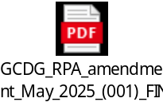

"C:\Users\majed.ghannam\OneDrive - United Nations Development Programme\Desktop\October 2023 projects\ٍtemporiry shelter\King Suliman Relief\IP-GCDG\PEF\PEF RPA_sep 2025-PEF-Majed.docx"

Annex 2

Approved communications plan included in the proposal

The Emergency Intervention for Relief in the Gaza Strip
The Emergency Intervention for Relief in the Gaza Strip, implemented by UNDP/PAPP with funding from KS Relief, addresses urgent needs in the water and solid waste sectors due to the ongoing conflict. The project delivers safe drinking water to 600,000 displaced and crisis-affected individuals and supports solid waste collection services for over 400,000 people in southern and northern Gaza. These efforts aim to restore public health, reduce environmental hazards, and strengthen the resilience of Gaza’s most vulnerable communities over a 12-month implementation period.
By restoring essential WASH services, the project enhances public health, mitigates environmental risks, and strengthens the resilience of vulnerable communities in Gaza.
Achieved in Green
In the pipeline yellow
Activity | Description of communications activities | Communication Medium | Target Audience | Timeline
Press Releases | Develop and distribute joint press release acknowledging KSR contributions and highlighting kicking on the activities | Local and International Media Outlets | General Public, Donors, Partners, Media Representatives | March
Feature Stories | Develop and publish 2 feature articles for each of the two components (waster and solid waste) | Websites, Local and International Media | General Public, Partners, Donors | November 2025  January 2026
Media and Journalists field visits | 2 visits to be organized | Media persons | General Public, Partners, Donors | September 2025  January 2026
Procurement of 5 potable water distribution tankers (10 m³ capacity) | 1 press release distributed. | UNDP/PAPP Social Media Channels | General Public, Donors, Civil Society, UN Agencies | Upon arrival
 | 2 digital content pieces for social media | UNDP/PAPP Social Media Channels | General Public, Donors, Civil Society, UN Agencies | Upon arrival
 | 1 short video with beneficiaries and project team | UNDP/PAPP Social Media Channels | General Public, Donors, Civil Society, UN Agencies | Upon arrival
Daily water trucking to IDPs and host communities (1,800 m³/day using 36 tankers) | 2 digital content pieces on distribution | UNDP/PAPP Social Media Channels | General Public, Donors, Civil Society, UN Agencies | June 2025
 | 1 video showing the process | UNDP/PAPP Social Media Channels | General Public, Donors, Civil Society, UN Agencies | June 2025
 | 1 digital media content on beneficiaries | UNDP/PAPP Social Media Channels | General Public, Donors, Civil Society, UN Agencies | August 2025
Supply and distribution of jerrycans and buckets (20 liters each) | 1 video content around testimonies from beneficiaries | UNDP/PAPP Social Media Channels | General Public, Donors, Civil Society, UN Agencies | August 2025
 | 2 digital media content on importance of jerrycans and buckets | UNDP/PAPP Social Media Channels | General Public, Donors, Civil Society, UN Agencies | November 2025
Solid waste collection and transport in South Gaza and North of Gaza | 1 press release marking a milestone on solid waste collection | UNDP/PAPP Social Media Channels | General Public, Donors, Civil Society, UN Agencies | October 2025
 | 2 digital media content | UNDP/PAPP Social Media Channels | General Public, Donors, Civil Society, UN Agencies | August
 | 1 video of collection with testimonies from beneficiaries living around dumping sites | UNDP/PAPP Social Media Channels | General Public, Donors, Civil Society, UN Agencies | October 2025
Deployment of workers for waste removal and fuel distribution supervision | 2 digital contents for social media | UNDP/PAPP Social Media Channels | General Public, Donors, Civil Society, UN Agencies | August 2025
Rehabilitation and operation of temporary dumping sites (2 sites) | 2 digital contents for social media | UNDP/PAPP Social Media Channels | General Public, Donors, Civil Society, UN Agencies | October- December 2025
 | 1 video (before and after) | UNDP/PAPP Social Media Channels | General Public, Donors, Civil Society, UN Agencies | December 2025
- Infographics on expected results | Develop infographics and share on various platforms. | UNDP/PAPP Social Media Channels | General Public, Donors, Civil Society, UN Agencies | November 2025
- Full video at project completion | Produce a video documenting the project's achievements and outcomes. | UNDP/PAPP Social Media Channels | General Public, Donors, Civil Society, UN Agencies | End of project
Photo Documentation | Conduct photo documentation of project activities across all interventions. | Internal and External Reports, Social Media | Donors, Partners, Stakeholders | Over the implementation.

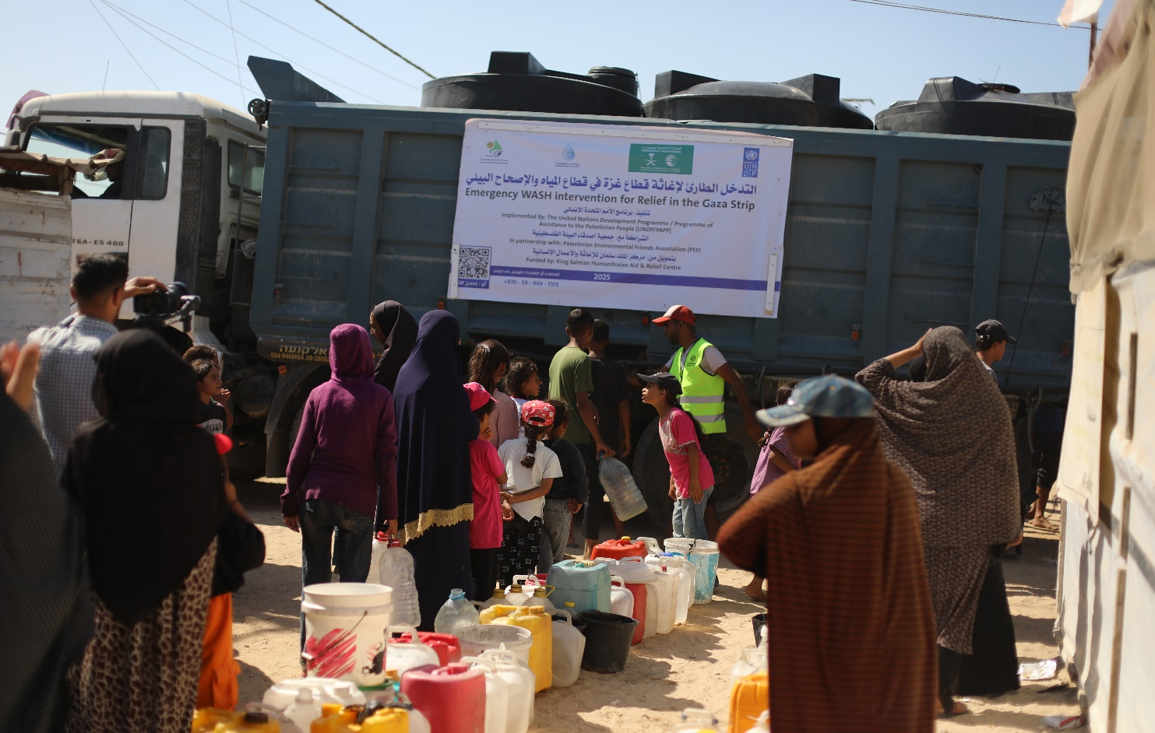
Safe Drinking Water Distribution
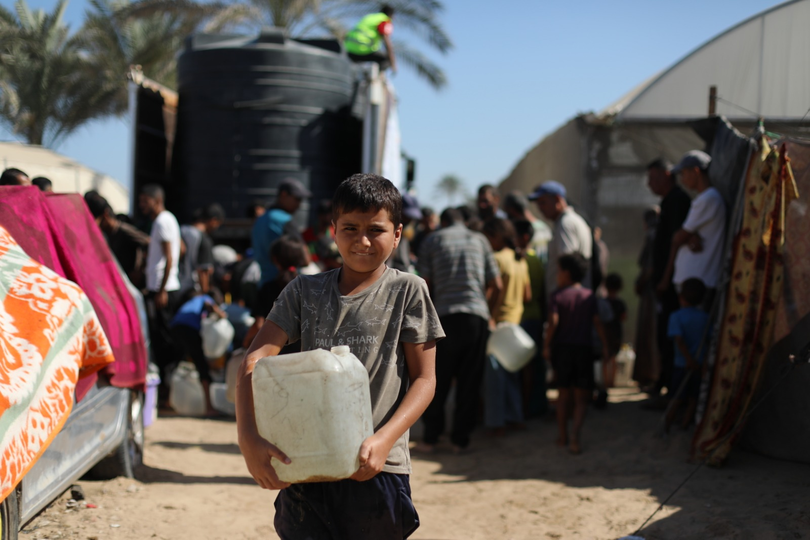

Safe Drinking Water Distribution
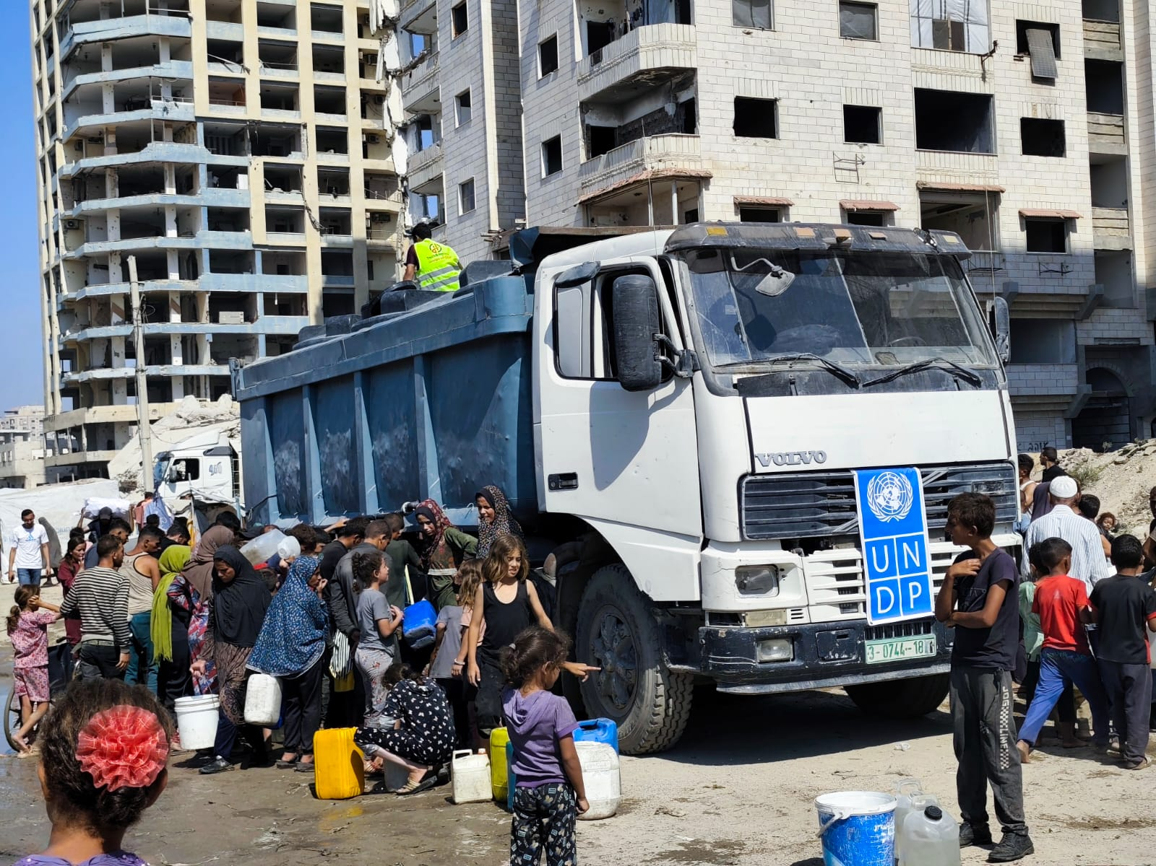
Safe Drinking Water Distribution
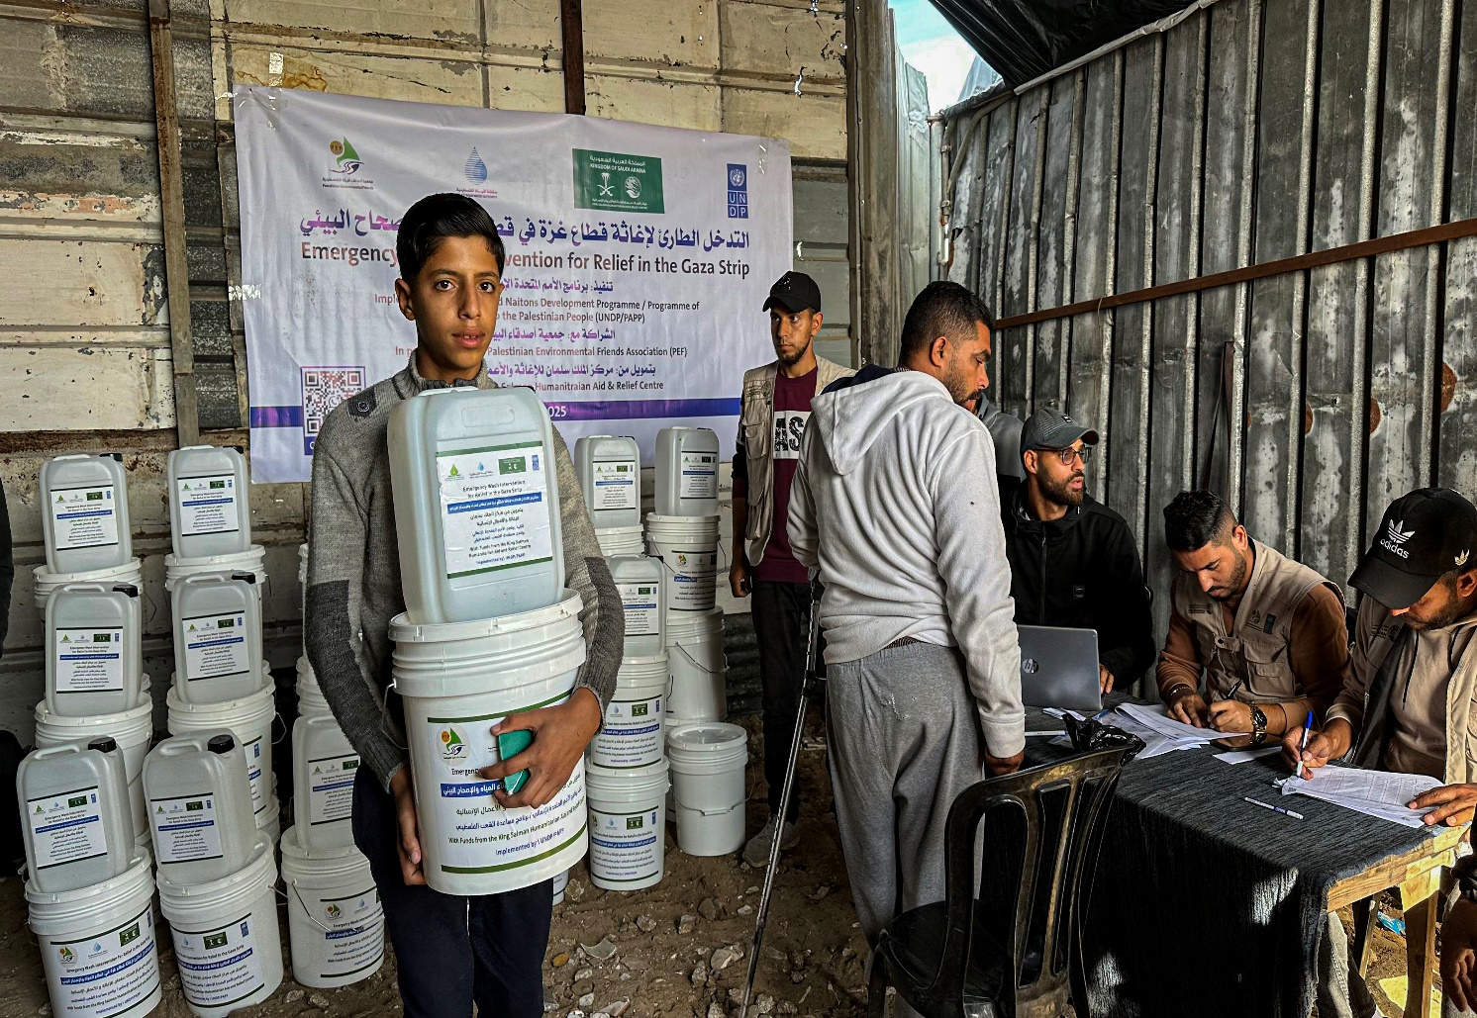
Distribution of gallons and buckets for beneficiaries of IDPs
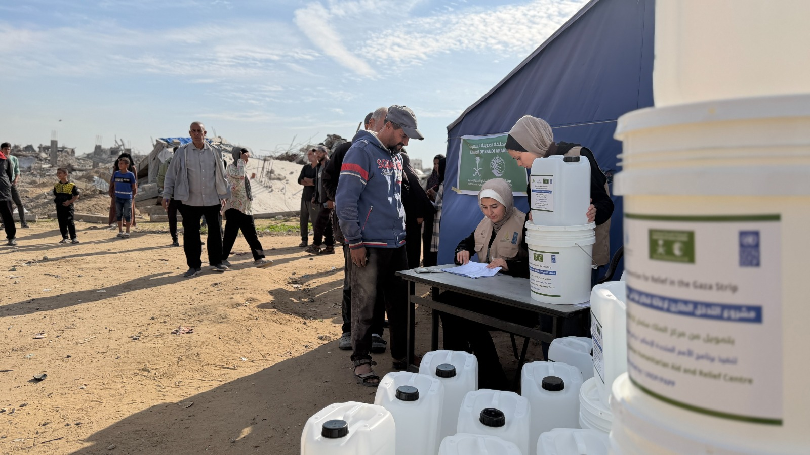
Distribution of gallons and buckets for beneficiaries of IDPs
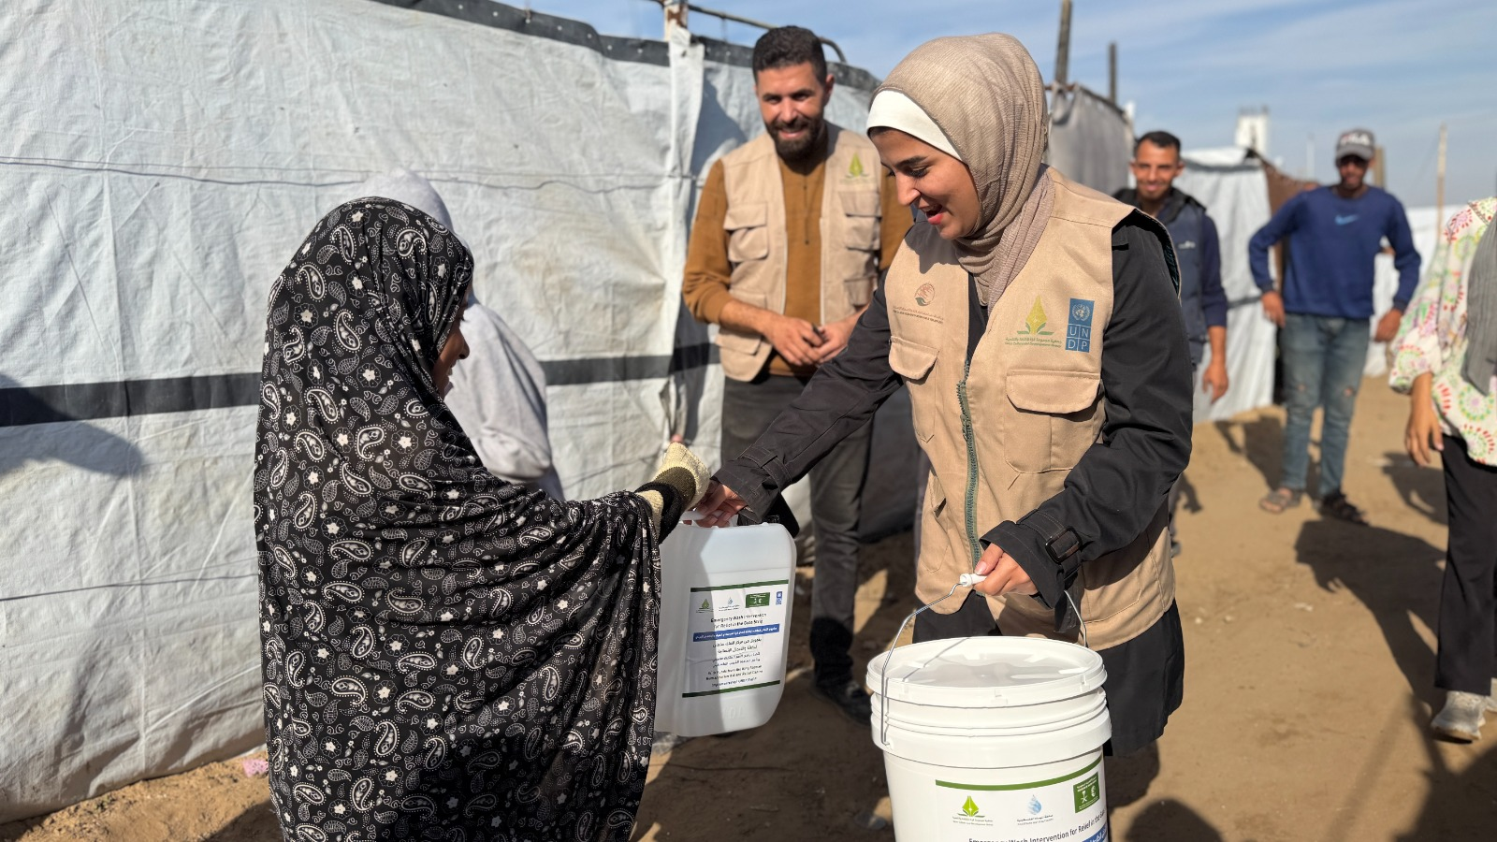

Distribution of gallons and buckets for beneficiaries of IDPs

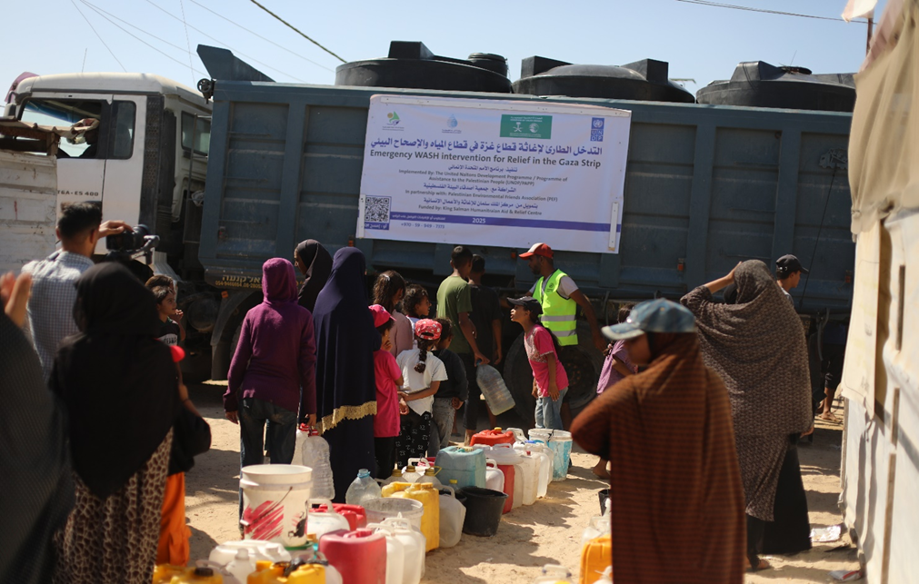 | 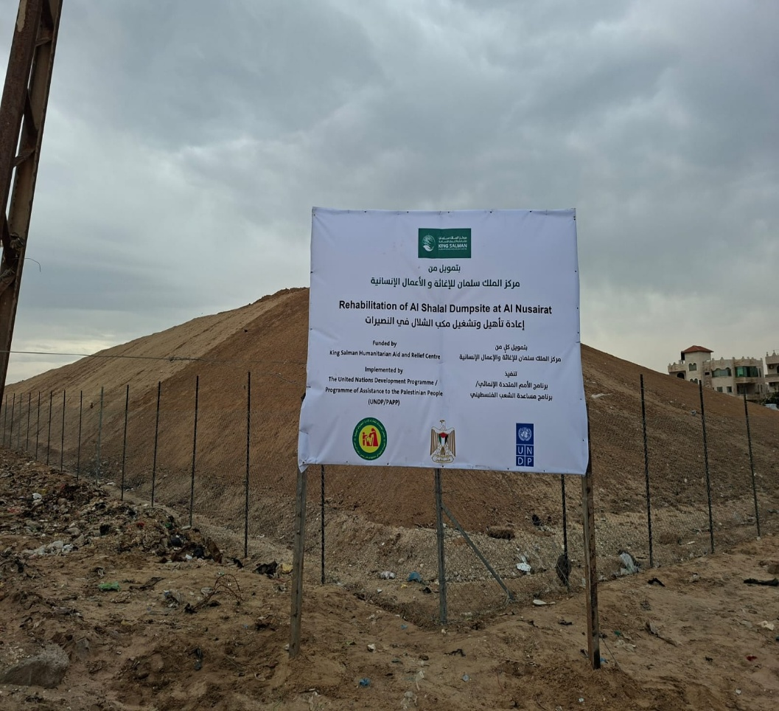
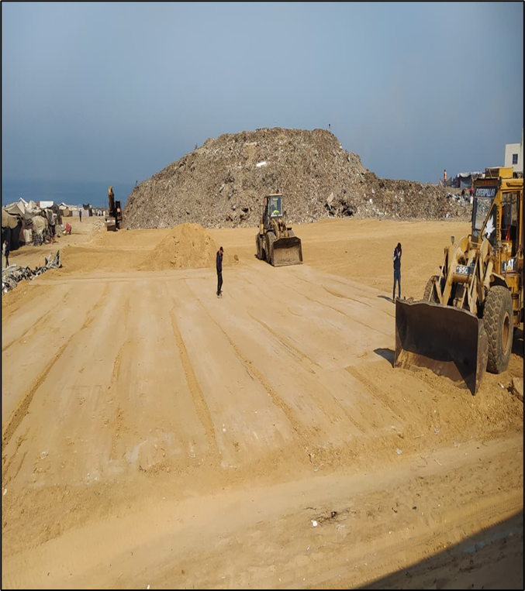  Al Shalal Rehabilitation dumpsite | 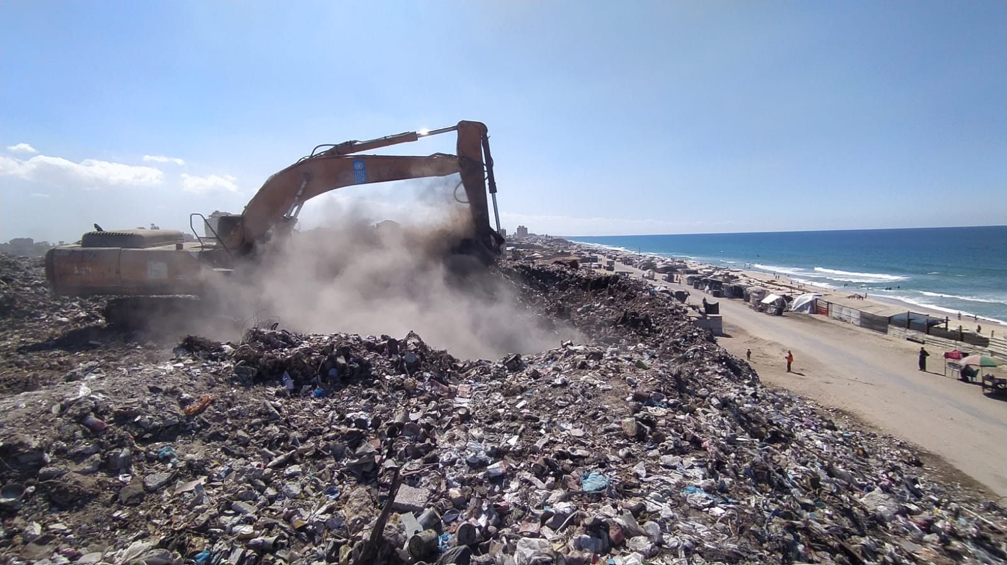  Al Shalal Rehabilitation dumpsite

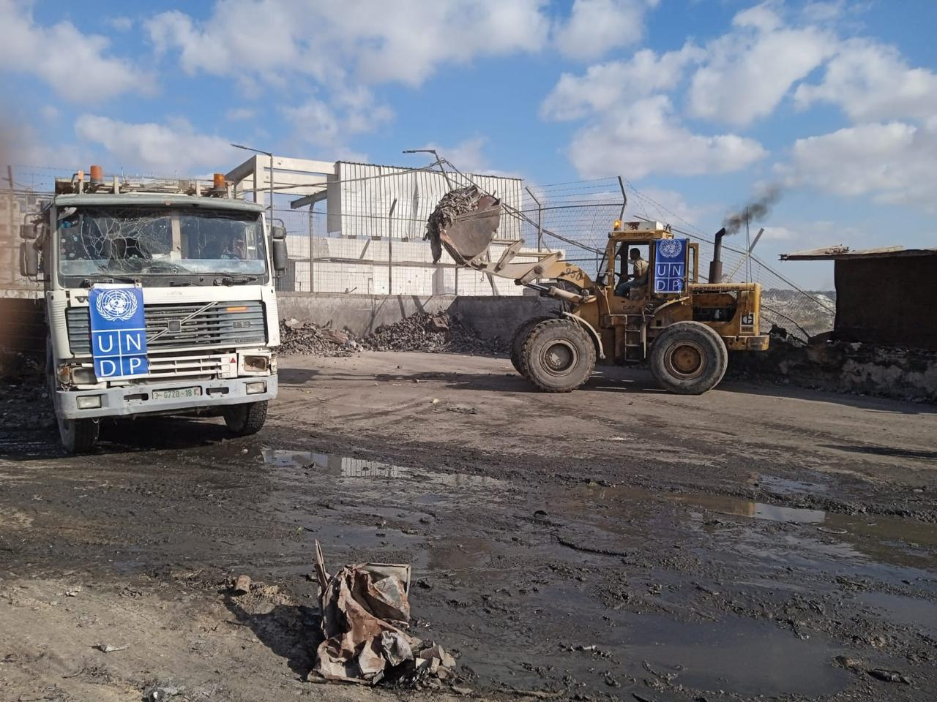  Secondary waste collection | 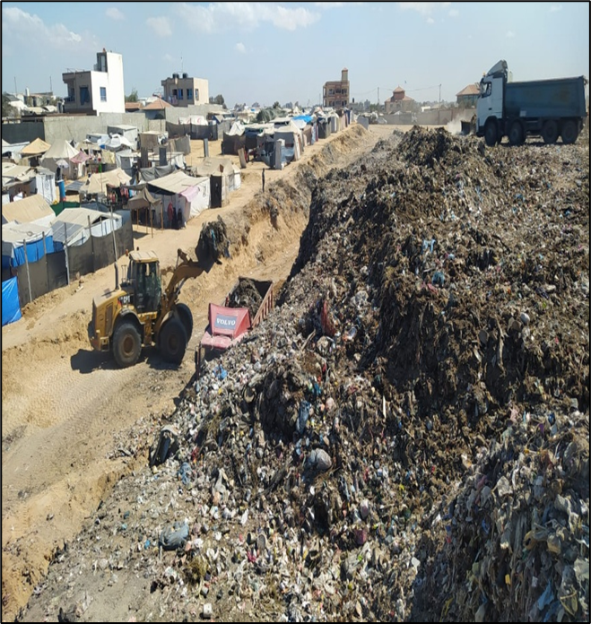  Al Shalal Rehabilitation dumpsite

OCHA Reported impact snapshot Day 278 | Gaza Strip (10 July 2024), online at: https://www.ochaopt.org/content/reported-impact-snapshot-gaza-strip-10-july-2024.

